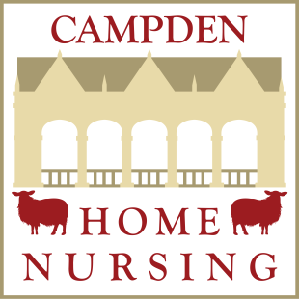
I would like to help Campden Home Nursing look after people with incurable illnesses.
There are many ways you can directly support us:
Make a one-off donation
Donate monthly through Standing Order
Leave us a Legacy in your Will (please call us on 01386 840505)
Trusts (please call us on 01386 840505)
My details are: Please complete this form and return it to:

Title:
Forename(s):
Surname:
Address:

Postcode:
Tel:
Email:
I wish to…
Make a one-off donation of: £
And enclose my cheque payable to Campden Home Nursing CIO
Donate £ monthly through a standing Order, my Bank details are as follows:

Bank Name:

Bank Address:

Account Name:

Sort Code:

Account Number

Payments to be made to:
Campden Home Nursing CIO

Account: Lloyds TSB, High Street, Chipping Campden, Gloucestershire, GL55 6HH

Account Number 18551160
Sort Code: 30-98-90

on the of each month until further notice.

Campden Home Nursing CIO
Camperdene Gallery
High Street
Chipping Campden
Gloucestershire
GL55 6AT
Tel: 01386 840505
www.campdenhomenursing.org

Gift Aid Declaration
Boost your donation by 25p of Gift Aid for every £1 you donate

I wish the charity to treat this donation as Gift Aid and to treat similarly all future donations that I make to the charity. I am a UK Taxpayer and understand that if I pay less income tax and/or Capital Gains Tax than the amount of the gift aid claimed on all my donations in that tax year it is my responsibility to pay any difference.

I declare that I am a taxpayer and I want the charity to treat my donation of
£
Which I made on the / /
(Date of cheque) and any future donations I make as Git Aid Donations
I would like Campden Home Nursing CIO to claim the tax back on this donation.
Please pay Campden Home Nursing by Standing Order from the account detailed on this instruction. I understand that this instruction may remain with Campden Home Nursing and, if so, details will be passed electronically to my Bank/Building Society.
Date:
Signature:

